Name: FusionByte IT Consultation & Solutions
Reference website: www.tcs.com

🧭 HEADER (FINAL STRUCTURE)
LOGO | What We Do ▼ | Solutions | Who We Are ▼ | Careers ▼ | Contact Us | [ Get a Quote]
- Logo → Home
- Get a Quote → Primary CTA (right aligned, highlighted)

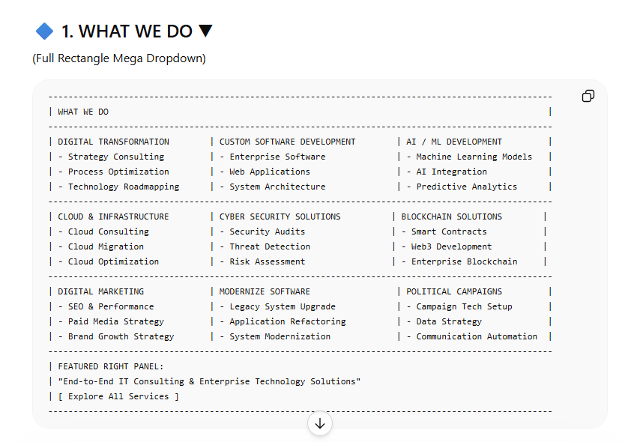

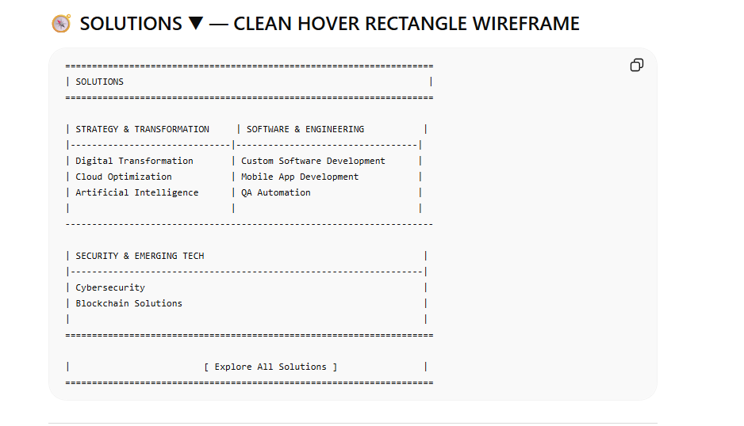
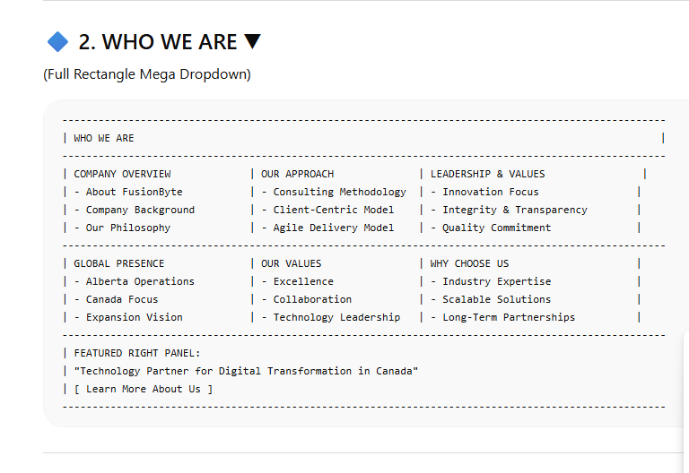
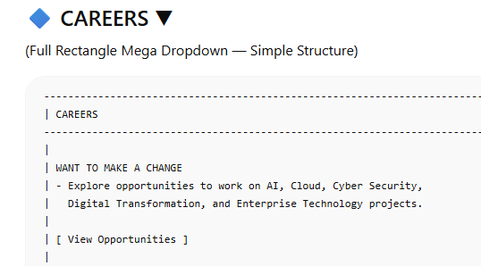

🧾 FUSIONBYTE IT — HOME PAGE WIREFRAME (ENTERPRISE STYLE)
====================================================================================================================
| GLOBAL HEADER |
====================================================================================================================
| LOGO | What We Do ▼ | Solutions ▼ | Who We Are ▼ | Careers ▼ | Contact Us | [ Get a Quote ] |
====================================================================================================================
====================================================================================================================
| HERO SECTION — 3D / MOVING BANNER (FULL WIDTH) |
====================================================================================================================
| (Animated Background: Subtle 3D motion, gradient, tech visuals, digital grid, cloud movement) |
| |
| CENTER CONTENT OVERLAY: |
| |
| MAIN QUOTE (Rotating / Sliding Quotes Style) |
| |
| "Transforming Businesses Through Intelligent Technology Solutions." |
| |
| "Driving Digital Transformation Across Canada." |
| |
| "Innovation. Security. Scalability." |
| |
| PRIMARY CTA BUTTON: |
| [ Explore Our Solutions ] |
| |
| SECONDARY CTA BUTTON: |
| [ Get a Quote ] |
====================================================================================================================
====================================================================================================================
| SECTION: WHAT WE DO (BRIEF INTRO) |
====================================================================================================================
| Photo on left and then heading and description on right

H2: Our Technology Services |
| |
| SHORT PARAGRAPH (SEO OPTIMIZED): |
| Fusion Byte provides enterprise-grade IT consulting and technology solutions including AI/ML development, cloud consulting, cybersecurity, digital transformation, software modernization, digital marketing, and political campaign technology solutions across Alberta and Canada. |
====================================================================================================================
====================================================================================================================
| SERVICES SECTION — IMAGE CARDS ONLY (NO DESCRIPTIONS) [clickable cards going to particular service on service page] |
====================================================================================================================
| H2: Our Core Services |
| |
| GRID LAYOUT (Image Cards + Title Only) |
| |
| [ IMAGE ] AI / ML Development |
| |
| [ IMAGE ] Modernize Software |
| |
| [ IMAGE ] Cloud Consulting Services |
| |
| [ IMAGE ] Cyber Security Solutions |
| |
| [ IMAGE ] Digital Marketing |
| |
| [ IMAGE ] Political Campaign Technology |
====================================================================================================================
====================================================================================================================
| SOLUTIONS SECTION — IMAGE CARDS ONLY [ clickable cards going to particular solution ] |
====================================================================================================================
| H2: Our Technology Solutions |
| |
| GRID LAYOUT (Image Cards + Title Only) |
| |
| [ IMAGE ] Digital Transformation |
| |
| [ IMAGE ] Custom Software Development |
| |
| [ IMAGE ] Mobile App Development |
| |
| [ IMAGE ] QA Automation |
| |
| [ IMAGE ] Cloud Optimization |
| |
| [ IMAGE ] Cyber Security |
| |
| [ IMAGE ] Artificial Intelligence |
| |
| [ IMAGE ] Blockchain Solutions |
====================================================================================================================
====================================================================================================================
| WHO WE ARE — BRIEF SECTION |
====================================================================================================================
| H2: Who We Are |
| |
| SHORT PROFESSIONAL DESCRIPTION: |
| Fusion Byte IT Consultation and Solutions is an Alberta-based technology company focused on delivering scalable digital transformation services for businesses seeking innovation, security, and operational efficiency. |
| |
| BUTTON: |
| [ Learn More About Us ] |
====================================================================================================================
====================================================================================================================
| PROCESS SECTION — AFTER YOU GET A QUOTE |
====================================================================================================================
| H2: How Our Process Works |
| |
| STEP FLOW (VISUAL ICON STYLE) |
| |
| STEP 1: Submit Your Request |
| User clicks “Get a Quote” or contacts us. |
| |
| STEP 2: Consultation & Requirement Analysis |
| Our team reviews your project needs and goals. |
| |
| STEP 3: Proposal & Solution Design |
| We present a structured plan with timeline and cost. |
| |
| STEP 4: Project Execution |
| Development, implementation, testing, and delivery. |
| |
| STEP 5: Support & Optimization |
| Ongoing improvements and technical support. |
====================================================================================================================
====================================================================================================================
| CTA SECTION (STRONG CONVERSION BLOCK) |
====================================================================================================================
| FULL WIDTH BACKGROUND IMAGE: Technology + Team Collaboration |
| |
| HEADLINE: Ready to Start Your Digital Transformation? |
| |
| SUBTEXT: |
| Connect with our team to discuss your project, request a proposal, or explore enterprise technology solutions tailored to your business. |
| |
| BUTTONS: |
| [ Contact Us ] |
| [ Get a Quote ] |
====================================================================================================================
====================================================================================================================
| FOOTER (CLEAN ENTERPRISE STYLE — NO POLICY LINKS) |
====================================================================================================================
| LOGO |
| "Transforming Businesses Through Intelligent Technology Solutions." |
| |
| Quick Links: |
| What We Do | Who We Are | Careers | Contact Us |
| |
| Services: |
| AI / ML | Cloud Consulting | Cyber Security | Software Development |
| |
| Contact Information: |
| Email | Address |
|

| Social Media: Fb | Instagram | X |
| © Fusion Byte IT Consultation and Solutions |
=========================================================================================================
🧾 FUSIONBYTE IT — WHAT WE DO PAGE WIREFRAME (ENTERPRISE + SEO)
====================================================================================================================
| PAGE: WHAT WE DO |
====================================================================================================================
| GLOBAL HEADER |
====================================================================================================================
| LOGO | What We Do ▼ | Solutions ▼ | Who We Are ▼ | Careers ▼ | Contact Us | [ Get a Quote ] |
====================================================================================================================
====================================================================================================================
| HERO BANNER (FULL WIDTH, MODERN ENTERPRISE STYLE) |
====================================================================================================================
| Background: Subtle animated tech visuals / digital grid / cloud motion |
| |
| H1: Enterprise Technology Solutions for Digital Transformation |
| |
| Subheading: |
| Fusion Byte delivers AI, cloud, cybersecurity, software modernization, digital marketing, and political technology solutions designed to help organizations innovate, scale, and operate efficiently across Canada. |
| |
| |
| CTA BUTTONS: |
| [ Request a Service ] → Links to Get a Quote Page |
| [ Explore Solutions ] |
====================================================================================================================
====================================================================================================================
| SECTION: AI / ML DEVELOPMENT |
====================================================================================================================
| IMAGE: AI models, data analytics dashboard, machine learning visualization |
| |
| TITLE: AI / ML Development |
| |
| PARAGRAPH (SEO 12–14 lines): |
Fusion Byte delivers advanced Artificial Intelligence and Machine Learning development services designed to help organizations transform data into actionable intelligence. Our AI solutions include predictive modeling, natural language processing, computer vision applications, recommendation systems, automation workflows, and intelligent data processing architectures. We build custom AI models tailored to business objectives, operational requirements, and industry use cases. Our development process focuses on data preparation, model training, validation, deployment, and continuous optimization. We design scalable AI frameworks that integrate seamlessly with existing enterprise systems and cloud environments. Security, performance, and structured implementation are central to every AI project we deliver. Whether businesses require automation enhancement, data-driven decision support, or intelligent system integration, FusionByte provides production-ready AI solutions aligned with digital transformation strategies. Our goal is to enable smarter operations, improved efficiency, and long-term technological competitiveness. | |
| CTA: [ Request AI Services ] |
====================================================================================================================
====================================================================================================================
| SECTION: MODERNIZE SOFTWARE |
====================================================================================================================
| IMAGE: Legacy system transformation / application refactoring diagram |
| |
| TITLE: Modernize Software |
| |
| PARAGRAPH: Fusion Byte specializes in modernizing legacy software systems to improve performance, scalability, security, and long-term maintainability. Many organizations operate on outdated platforms that limit efficiency and innovation. Our software modernization services include system refactoring, architecture redesign, performance optimization, API integration, UI/UX improvement, and cloud migration strategies. We analyze existing infrastructure, identify technical debt, and develop structured transition plans that minimize disruption. Our approach ensures business continuity while upgrading systems to modern frameworks and technologies. We focus on improving application responsiveness, system interoperability, and operational reliability. Whether migrating to cloud-native environments or upgrading enterprise platforms, Fusion Byte delivers strategic modernization solutions that align with digital transformation goals. Our objective is to extend system lifespan, enhance user experience, and support future scalability. |
| |
| CTA: [ Request Modernization ] |
====================================================================================================================
====================================================================================================================
| SECTION: CLOUD CONSULTING SERVICES |
====================================================================================================================
| IMAGE: Cloud infrastructure, servers, migration dashboard |
| |
| TITLE: Cloud Consulting Services |
| |
| PARAGRAPH: Fusion Byte provides comprehensive cloud consulting services that help organizations design, implement, and optimize secure cloud environments. Our expertise includes cloud migration planning, infrastructure architecture, workload optimization, hybrid cloud deployment, and performance enhancement strategies. We assist businesses in transitioning from on-premise systems to scalable cloud platforms while maintaining security, compliance, and operational stability. Our cloud solutions are structured to improve resource efficiency, reduce infrastructure costs, and increase system availability. We evaluate existing architecture, develop migration roadmaps, and implement optimization frameworks tailored to enterprise requirements. Security configuration, data management strategies, and scalability planning are integral parts of our consulting process. Whether organizations require cloud transformation or optimization of existing environments, Fusion Byte delivers reliable and scalable cloud strategies designed for long-term digital growth.
| |
| CTA: [ Request Cloud Consulting ] |
====================================================================================================================
====================================================================================================================
| SECTION: CYBER SECURITY SOLUTIONS |
====================================================================================================================
| IMAGE: Security operations center / threat detection visualization |
| |
| TITLE: Cyber Security Solutions |
| |
| PARAGRAPH: |
Fusion Byte provides comprehensive cybersecurity solutions designed to protect organizations from evolving digital threats, data breaches, and unauthorized access. Our security services include vulnerability assessments, risk analysis, security architecture design, threat detection strategies, and infrastructure hardening. We implement layered security frameworks that strengthen networks, applications, cloud environments, and enterprise systems. Our approach focuses on proactive monitoring, identity and access management, compliance alignment, and secure system design. We help businesses identify weaknesses, reduce cyber risks, and establish structured defense mechanisms. Whether organizations require security audits, incident response planning, or ongoing protection strategies, our team delivers scalable and enterprise-grade cybersecurity solutions. Our goal is to safeguard digital assets while ensuring operational continuity and regulatory readiness. |
| |
| CTA: [ Request Security Assessment ] |
====================================================================================================================
====================================================================================================================
| SECTION: DIGITAL MARKETING |
====================================================================================================================
| IMAGE: Marketing analytics dashboard / SEO performance graph |
| |
| TITLE: Digital Marketing |
| |
| PARAGRAPH: |
Fusion Byte delivers strategic digital marketing services focused on improving brand visibility, customer engagement, and online growth. Our services include search engine optimization, performance marketing, content strategy, conversion optimization, and data-driven campaign planning. We design structured marketing frameworks that enhance website traffic, generate qualified leads, and strengthen digital presence. Our team applies analytics-based strategies to improve search rankings, optimize user experience, and increase audience reach. We integrate marketing technology tools to measure performance, refine campaigns, and deliver consistent growth outcomes. Every strategy is aligned with business objectives, target audiences, and competitive positioning. Our digital marketing solutions are designed to support long-term brand development and measurable return on investment. |
| |
| CTA: [ Request Marketing Strategy ] |
====================================================================================================================
====================================================================================================================
| SECTION: POLITICAL CAMPAIGN TECHNOLOGY |
====================================================================================================================
| IMAGE: Campaign data analytics / communication strategy dashboard |
| |
| TITLE: Political Campaign Technology |
| |
| PARAGRAPH: |
| Fusion Byte provides secure and structured technology solutions for political campaigns requiring digital organization, communication systems, and data management support. Our services include campaign infrastructure setup, communication workflow design, digital engagement tools, analytics tracking, and secure data handling strategies. We help campaigns implement technology systems that support structured outreach, audience segmentation, performance monitoring, and operational coordination. Our approach emphasizes security, scalability, and responsible data management. We design systems that enhance communication efficiency while maintaining transparency and control. Whether supporting digital strategy planning or campaign technology optimization, Fusion Byte delivers professional-grade infrastructure aligned with organizational requirements. Our solutions are built to support structured operations and data-driven decision-making. |
| |
| CTA: [ Request Campaign Consultation] |
====================================================================================================================

Image: Blockchain network visualization, smart contract diagram, decentralized system graphic

Title: Blockchain Solutions

Paragraph (12–14 Lines):

Fusion Byte offers blockchain development and consulting services designed to support secure, decentralized, and transparent digital systems. Our blockchain solutions include smart contract development, distributed application architecture, enterprise blockchain integration, and system design consulting. We help organizations explore blockchain applications for data verification, secure transactions, process automation, and digital record management. Our team focuses on scalable architecture, security optimization, and seamless system integration. Whether businesses require private blockchain implementation or decentralized application support, we deliver structured and production-ready solutions. Our blockchain services are designed to enhance trust, improve operational transparency, and support next-generation digital transformation strategies. We ensure that blockchain implementations align with enterprise goals and technical standards.

CTA: [ Request Blockchain Services ]
====================================================================================================================
| ADDITIONAL SECTION: WHY CHOOSE FUSIONBYTE |
====================================================================================================================
| H2: Why Organizations Choose Us |
| |
| 4 VALUE POINTS (ICONS STYLE) |
| - Enterprise-Level Expertise |
| - Scalable Technology Architecture |
| - Security-First Development |
| - Long-Term Strategic Partnership |
====================================================================================================================
====================================================================================================================
| FINAL CTA SECTION |
====================================================================================================================
| Background: Modern tech collaboration image |
| |
| H2: Ready to Start Your Project? |
| |
| Subtext: |
| Contact our team today to request a customized proposal or discuss your technology requirements. |
| |
| BUTTONS: |
| [ Contact Us ] |
| [ Get a Quote ] |
====================================================================================================================
====================================================================================================================
| FOOTER (CLEAN ENTERPRISE STYLE)

🧾 FUSIONBYTE IT — SOLUTIONS PAGE WIREFRAME
====================================================================================================================
| PAGE: SOLUTIONS |
====================================================================================================================
| GLOBAL HEADER |
====================================================================================================================
| LOGO | What We Do ▼ | Solutions ▼ | Who We Are ▼ | Careers ▼ | Contact Us | [ Get a Quote ] |
====================================================================================================================
====================================================================================================================
| HERO BANNER (FULL WIDTH ENTERPRISE STYLE) |
====================================================================================================================
| Background: Digital transformation visuals / enterprise architecture / innovation theme |
| |
| H1: Strategic Technology Solutions for Modern Enterprises |
| |
| Subheading: |
| FusionByte delivers outcome-driven solutions in digital transformation, custom software development, mobile applications, QA automation, cloud optimization, cybersecurity, artificial intelligence, and blockchain. |
| |
| |
| CTA BUTTONS: |
| [ Explore Our Services ] |
| [ Get a Quote ] |
====================================================================================================================
####################################################################################################################
# SOLUTION 1 — DIGITAL TRANSFORMATION #
####################################################################################################################
IMAGE: Enterprise transformation diagram / workflow modernization
TITLE: Digital Transformation
PARAGRAPH (12–14 Lines):
Fusion Byte provides comprehensive digital transformation solutions designed to help organizations modernize operations, improve efficiency, and adopt advanced technologies. Our approach integrates AI, cloud computing, automation, cybersecurity, and software modernization into a unified strategic roadmap. We evaluate existing systems, identify improvement opportunities, and design structured transformation plans aligned with business objectives. Digital transformation is not only about technology upgrades but also process optimization, system integration, and performance enhancement. We help enterprises reduce manual workflows, improve data visibility, strengthen security frameworks, and increase scalability. Our solutions are tailored for long-term growth, operational resilience, and competitive advantage. Fusion Byte ensures that transformation initiatives are practical, measurable, and strategically implemented.
CTA: [ Request Digital Strategy ]
####################################################################################################################
####################################################################################################################
# SOLUTION 2 — CUSTOM SOFTWARE DEVELOPMENT #
####################################################################################################################
IMAGE: Application architecture / development workflow
TITLE: Custom Software Development
PARAGRAPH:
Fusion Byte designs and develops custom software solutions tailored to unique business requirements. We build scalable applications, enterprise platforms, internal management systems, and customer-facing digital products. Our development process includes requirement analysis, system architecture planning, secure coding practices, testing, deployment, and long-term maintenance strategies. Custom software enables organizations to eliminate limitations of off-the-shelf tools and create systems that align precisely with operational workflows. We focus on performance optimization, security integration, and seamless scalability. Whether building from scratch or enhancing existing platforms, our solutions are engineered for reliability and long-term sustainability.
CTA: [ Request Development Plan ]
####################################################################################################################
####################################################################################################################
# SOLUTION 3 — MOBILE APP DEVELOPMENT #
####################################################################################################################
IMAGE: Mobile application interface / cross-platform development
TITLE: Mobile App Development
PARAGRAPH:
Fusion Byte delivers cross-platform and native mobile application development services for businesses seeking to expand digital engagement. We design user-friendly applications for iOS and Android with secure backend integration and scalable architecture. Our mobile solutions support customer interaction, internal operations, data management, and service delivery. From concept design and UI/UX development to deployment and optimization, we provide end-to-end mobile strategy. Applications are built with performance efficiency, security standards, and future expandability in mind. Our goal is to create intuitive, reliable, and business-aligned mobile solutions.
CTA: [ Start Your App Project ]
####################################################################################################################
####################################################################################################################
# SOLUTION 4 — QA AUTOMATION #
####################################################################################################################
IMAGE: Testing automation dashboard / quality assurance workflow
TITLE: QA Automation
PARAGRAPH:
Fusion Byte offers quality assurance and automation services to ensure software reliability, performance, and stability. Our QA automation solutions include test framework development, continuous integration testing, regression testing, performance validation, and system monitoring strategies. Automated testing reduces development errors, improves deployment speed, and enhances system consistency. We implement structured quality assurance pipelines that integrate with modern development workflows. Our approach increases efficiency, reduces operational risks, and ensures enterprise-grade software reliability.
CTA: [ Request QA Consultation ]
####################################################################################################################
####################################################################################################################
# SOLUTION 5 — CLOUD OPTIMIZATION #
####################################################################################################################
IMAGE: Cloud infrastructure optimization diagram
TITLE: Cloud Optimization
PARAGRAPH:
Fusion Byte provides cloud optimization strategies designed to improve performance, reduce operational costs, and enhance infrastructure efficiency. We analyze existing cloud environments, identify resource inefficiencies, and implement optimization frameworks for better scalability. Our solutions include workload balancing, architecture refinement, cost management strategies, and security enhancements. Cloud optimization ensures businesses achieve maximum value from their cloud investments while maintaining high availability and compliance standards. We support hybrid, private, and public cloud environments.
CTA: [ Optimize Your Cloud ]
####################################################################################################################
####################################################################################################################
# SOLUTION 6 — CYBERSECURITY #
####################################################################################################################
IMAGE: Security operations center / threat monitoring system
TITLE: Cyber Security
PARAGRAPH:
Fusion Byte delivers enterprise cybersecurity solutions focused on risk mitigation, vulnerability assessment, and infrastructure protection. Our services include security audits, threat detection systems, identity management strategies, compliance alignment, and secure architecture design. We help organizations safeguard data, protect digital assets, and reduce exposure to cyber threats. Our security frameworks are designed for scalability, regulatory compliance, and continuous monitoring. Cybersecurity is integrated into every stage of system development and infrastructure planning.
CTA: [ Request Security Review ]
####################################################################################################################
####################################################################################################################
# SOLUTION 7 — ARTIFICIAL INTELLIGENCE #
####################################################################################################################
IMAGE: AI analytics dashboard / machine learning visualization
TITLE: Artificial Intelligence
PARAGRAPH:
Fusion Byte designs and implements artificial intelligence solutions that enable automation, predictive insights, and intelligent decision-making. Our AI services include machine learning model development, data analytics systems, natural language processing, and automation frameworks. We build scalable AI architectures that integrate seamlessly with enterprise platforms. Our solutions are structured for secure deployment, performance optimization, and long-term adaptability. AI implementation supports operational efficiency and strategic innovation across industries.
CTA: [ Explore AI Solutions ]
####################################################################################################################
####################################################################################################################
# SOLUTION 8 — BLOCKCHAIN SOLUTIONS #
####################################################################################################################
IMAGE: Blockchain network visualization / decentralized system diagram
TITLE: Blockchain Solutions
PARAGRAPH:
Fusion Byte provides blockchain consulting and development services for organizations seeking secure, transparent, and decentralized systems. Our blockchain solutions include smart contract development, enterprise blockchain architecture, and distributed application design. We help businesses implement secure digital record systems, transactional frameworks, and verification models. Our approach ensures scalability, data integrity, and structured system integration. Blockchain technology can enhance trust, transparency, and automation across digital ecosystems.
CTA: [ Request Blockchain Consultation ]
####################################################################################################################
====================================================================================================================
| FINAL CTA SECTION |
====================================================================================================================
| Background: Enterprise collaboration visual |
| |
| H2: Ready to Build Your Technology Solution? |
| |
| Text: |
| Contact Fusion Byte to discuss your solution requirements and receive a structured proposal tailored to your business needs. |
| |
| BUTTONS: |
| [ Contact Us ] |
| [ Get a Quote ] |
====================================================================================================================
====================================================================================================================
| FOOTER |
===========================

🧾 FUSIONBYTE IT — WHO WE ARE PAGE WIREFRAME
====================================================================================================================
| PAGE: WHO WE ARE |
====================================================================================================================
| GLOBAL HEADER |
====================================================================================================================
| HERO SECTION — FULL WIDTH BANNER |
====================================================================================================================
| Background: Modern enterprise tech visuals / digital transformation animation |
| |
| H1: About FusionByte IT Consultation and Solutions |
| |
| Subheading: |
| An Alberta-Based Technology Consulting Company Delivering AI, Cloud, Cybersecurity, Software Modernization, and Digital Transformation Solutions. |
| |
|
| |
| CTA BUTTONS: |
| [ Explore Our Services ] |
| [ Get a Quote ] |
====================================================================================================================
====================================================================================================================
| SECTION: COMPANY OVERVIEW |
====================================================================================================================
| H2: Who We Are |
| |
| IMAGE: Corporate technology team / strategy meeting / enterprise collaboration |
| |
| PARAGRAPH (SEO OPTIMIZED): |
| Fusion Byte IT Consultation and Solutions is a technology-focused consulting company based in Alberta, Canada, dedicated to delivering enterprise-grade digital solutions for organizations seeking innovation, scalability, and operational efficiency. We specialize in AI/ML development, cloud consulting services, cybersecurity solutions, software modernization, digital marketing strategies, blockchain development, and political campaign technology support. Our approach combines structured planning, technical expertise, and scalable architecture to help businesses achieve digital transformation goals. We focus on building reliable, secure, and future-ready technology systems that support long-term growth. |
====================================================================================================================
====================================================================================================================
| SECTION: OUR MISSION |
====================================================================================================================
| H2: Our Mission |
| |
| IMAGE: Technology roadmap / digital strategy diagram |
| |
| PARAGRAPH: |
| Our mission is to deliver high-quality technology consulting and implementation services that empower organizations to modernize their systems, strengthen cybersecurity, adopt cloud technologies, integrate artificial intelligence, and improve overall digital performance. We are committed to providing structured, secure, and scalable solutions that align with business objectives and industry best practices. |
====================================================================================================================
====================================================================================================================
| SECTION: OUR VISION |
====================================================================================================================
| H2: Our Vision |
| |
| IMAGE: Futuristic enterprise technology environment |
| |
| PARAGRAPH: |
| Our vision is to become a trusted technology partner for businesses across Canada by delivering innovative, secure, and scalable digital transformation solutions. We aim to support organizations in adopting advanced technologies, improving operational efficiency, and building resilient systems that enable sustainable growth in a competitive digital landscape. |
====================================================================================================================
====================================================================================================================
| SECTION: OUR VALUES |
====================================================================================================================
| H2: Our Core Values |
| |
| GRID (ICON CARDS) |
| |
| CARD 1: Innovation |
| Driving forward-thinking technology solutions. |
| |
| CARD 2: Security-First Approach |
| Designing systems with enterprise-level protection. |
| |
| CARD 3: Scalability |
| Building solutions that grow with your business. |
| |
| CARD 4: Integrity |
| Transparent processes and structured delivery. |
====================================================================================================================
====================================================================================================================
| SECTION: OUR EXPERTISE |
====================================================================================================================
| H2: Areas of Expertise |
| |
| IMAGE GRID WITH TITLES ONLY |
| |
| - Artificial Intelligence & Machine Learning |
| - Cloud Consulting & Optimization |
| - Cybersecurity & Risk Management |
| - Custom Software Development |
| - Digital Transformation Strategy |
| - Blockchain Solutions |
| - Digital Marketing Technology |
| - Enterprise System Modernization |
====================================================================================================================
====================================================================================================================
| SECTION: WHY CHOOSE FUSIONBYTE |
====================================================================================================================
| H2: Why Organizations Work With Us |
| |
| 4 VALUE POINTS |
| |
| ✔ Enterprise-Level Technical Expertise |
| ✔ Structured Consulting Approach |
| ✔ Secure & Scalable Architectures |
| ✔ Long-Term Technology Partnership |
====================================================================================================================
====================================================================================================================
| SECTION: STRATEGIC APPROACH |
====================================================================================================================
| H2: Our Consulting Methodology |
| |
| STEP FLOW |
| |
| Step 1: Requirement Analysis |
| Step 2: Strategic Planning |
| Step 3: Solution Design |
| Step 4: Implementation & Deployment |
| Step 5: Optimization & Ongoing Support |
====================================================================================================================
====================================================================================================================
| FINAL CTA SECTION |
====================================================================================================================
| Background: Modern collaboration + digital transformation visuals |
| |
| H2: Partner With FusionByte for Your Next Technology Initiative |
| |
| Subtext: |
| Connect with our team to discuss enterprise solutions, project requirements, or long-term digital transformation strategies. |
| |
| BUTTONS: |
| [ Contact Us ] |
| [ Get a Quote ] |
====================================================================================================================
====================================================================================================================
| FOOTER |
================

🧾 FUSIONBYTE IT — CAREERS PAGE WIREFRAME
====================================================================================================================
| PAGE: CAREERS |
====================================================================================================================
====================================================================================================================
| HERO BANNER (FULL WIDTH) |
====================================================================================================================
| Background: Modern tech team / office collaboration / innovation visuals |
| |
| H1: Build Your Career in Technology & Innovation |
| |
| Subheading: |
| Join FusionByte IT Consultation and Solutions and work on AI, Cloud, |
| Cybersecurity, Digital Transformation, and Enterprise Technology projects |
| across Alberta and Canada. |
| |
| |
| PRIMARY CTA: |
| [ Join Us Today ] |
====================================================================================================================
====================================================================================================================
| SECTION: CURRENT OPENINGS (CARDS GRID) |
====================================================================================================================
| H2: Open Positions |
| |
| CARD 1 |
| [ IMAGE ] |
| Title: AI / ML Developer |
| Button: Learn More → Scrolls to Section Below |
| |
| CARD 2 |
| [ IMAGE ] |
| Title: Cloud Solutions Engineer |
| Button: Learn More → Scrolls to Section Below |
| |
| CARD 3 |
| [ IMAGE ] |
| Title: Cyber Security Analyst |
| Button: Learn More → Scrolls to Section Below |
====================================================================================================================
####################################################################################################################
# JOB SECTION 1 — AI / ML DEVELOPER #
####################################################################################################################
LEFT SIDE (JOB DETAILS)
H2: AI / ML Developer
Overview:
Fusion Byte is seeking an AI/ML Developer to design, develop, and deploy
intelligent systems, predictive models, and automation solutions.
This role involves working on artificial intelligence frameworks,
data modeling, machine learning pipelines, and enterprise integrations.
Responsibilities:
- Develop and train machine learning models
- Work with structured and unstructured data
- Build AI-powered automation systems
- Integrate AI solutions into enterprise applications
- Optimize model performance and scalability
Requirements:
- Experience in Python and AI frameworks
- Understanding of machine learning concepts
- Knowledge of data processing and model deployment
- Strong problem-solving skills
Why Join Us:
- Work on advanced AI projects
- Growth-focused environment
- Enterprise-level technology exposure
RIGHT SIDE (APPLICATION FORM)
Apply for this Position
Full Name *
[ Input ]
Email Address *
[ Input ]
Phone Number *
[ Input ]
Resume Upload (PDF/Word)
[ Upload File ]
Cover Letter
[ Text Area ]
[ Submit Application ]
####################################################################################################################
####################################################################################################################
# JOB SECTION 2 — CLOUD SOLUTIONS ENGINEER #
####################################################################################################################
LEFT SIDE (JOB DETAILS)
H2: Cloud Solutions Engineer
Overview:
We are hiring a Cloud Solutions Engineer to design, implement,
and optimize cloud infrastructure for enterprise clients.
The role focuses on cloud migration, architecture planning,
performance optimization, and secure deployments.
Responsibilities:
- Design cloud-based architectures
- Perform cloud migrations
- Optimize cloud performance
- Implement security best practices
- Work with hybrid environments
Requirements:
- Experience with cloud platforms
- Knowledge of infrastructure design
- Understanding of security and scalability
- Strong technical background
Why Join Us:
- Work on large-scale infrastructure
- Enterprise consulting exposure
- Innovative project environment
RIGHT SIDE (APPLICATION FORM)
Apply for this Position
Full Name *
[ Input ]
Email Address *
[ Input ]
Phone Number *
[ Input ]
Resume Upload
[ Upload File ]
Cover Letter
[ Text Area ]
[ Submit Application ]
####################################################################################################################
####################################################################################################################
# JOB SECTION 3 — CYBER SECURITY ANALYST #
####################################################################################################################
LEFT SIDE (JOB DETAILS)
H2: Cyber Security Analyst
Overview:
Fusion Byte is looking for a Cyber Security Analyst to support
risk assessments, vulnerability analysis, security monitoring,
and enterprise protection strategies for clients across Canada.
Responsibilities:
- Conduct security audits
- Identify vulnerabilities
- Monitor threats and system logs
- Implement security improvements
- Support compliance initiatives
Requirements:
- Knowledge of cybersecurity frameworks
- Understanding of risk management
- Analytical mindset
- Security tools experience
Why Join Us:
- Work in security-first environment
- Exposure to enterprise clients
- Career growth in cybersecurity
RIGHT SIDE (APPLICATION FORM)
Apply for this Position
Full Name *
[ Input ]
Email Address *
[ Input ]
Phone Number *
[ Input ]
Resume Upload
[ Upload File ]
Cover Letter
[ Text Area ]
[ Submit Application ]
####################################################################################################################
====================================================================================================================
| FOOTER

🧾 FUSIONBYTE IT — CONTACT US PAGE WIREFRAME
====================================================================================================================
| PAGE: CONTACT US |
====================================================================================================================
| GLOBAL HEADER |
====================================================================================================================
| HERO BANNER (FULL WIDTH) |
====================================================================================================================
| Background: Modern office / technology collaboration / digital grid |
| |
| H1: Contact FusionByte IT Consultation and Solutions |
| |
| Subheading: |
| Get in touch with our Alberta-based technology consulting team for AI development, cloud consulting, cybersecurity, digital transformation, software modernization, or enterprise technology solutions. |
|
| |
| CTA BUTTON: |
| [ Request a Consultation ] |
====================================================================================================================
====================================================================================================================
| SECTION: CONTACT INFORMATION + FORM (2 COLUMN LAYOUT) |
====================================================================================================================
LEFT SIDE — CONTACT DETAILS
H2: Reach Us Directly
Company Name:
Fusion Byte IT Consultation and Solutions
Location:
Alberta, Canada
Email:
info@fusionbyte.com
Short Description:
We respond to all inquiries within 1–2 business days.
For project discussions, partnerships, or service requests,
please use the form or click “Get a Quote”.
RIGHT SIDE — CONTACT FORM
H2: Send Us a Message
Full Name *
[ Input Field ]
Email Address *
[ Input Field ]
Phone Number *
[ Input Field ]
Company Name
[ Input Field ]
Service Interested In *
[ Dropdown ]
- AI / ML Development
- Cloud Consulting
- Cyber Security
- Software Modernization
- Digital Marketing
- Blockchain Solutions
- General Inquiry
Message *
[ Large Text Area ]
Preferred Contact Method
( ) Email
( ) Phone
[ Submit Message ]
====================================================================================================================
====================================================================================================================
| SECTION: REQUEST A PROJECT QUOTE |
====================================================================================================================
| H2: Looking for a Project Estimate? |
| |
| Text: |
| If you would like a detailed proposal, pricing information, or structured technology consulting support, please visit our dedicated Get a Quote page. |
| |
| BUTTON: |
| [ Get a Quote ] |
====================================================================================================================
====================================================================================================================
| SECTION: MAP (OPTIONAL BUT RECOMMENDED FOR LOCAL SEO) |
====================================================================================================================
| H2: Our Location |
| |
| Embedded Google Map: Alberta, Canada Office Location |
| |
| Text Below Map: |
| FusionByte is proudly based in Alberta and serves businesses across Canada with enterprise technology solutions and consulting services. |
====================================================================================================================
====================================================================================================================
| SECTION: WHY CONTACT US |
====================================================================================================================
| H2: Why Businesses Contact FusionByte |
| |
| ICON GRID: |
| ✔ AI & Automation Consultation |
| ✔ Cloud Migration Planning |
| ✔ Cybersecurity Assessment |
| ✔ Enterprise Software Strategy |
| ✔ Digital Transformation Roadmaps |
| ✔ Long-Term Technology Partnerships |
====================================================================================================================
====================================================================================================================
| FINAL CTA SECTION |
====================================================================================================================
| Background: Professional technology team image |
| |
| H2: Let’s Build Your Next Technology Solution |
| |
| Text: |
| Connect with our team today to discuss your requirements and explore scalable, secure, and innovative enterprise solutions. |
| |
| BUTTONS: |
| [ Contact Us ] |
| [ Get a Quote ] |
====================================================================================================================
====================================================================================================================
| FOOTER |
=======================

🧾 FUSIONBYTE IT — GET A QUOTE PAGE WIREFRAME
====================================================================================================================
| PAGE: GET A QUOTE |
====================================================================================================================
| GLOBAL HEADER |
=============================================================================
====================================================================================================================
| HERO BANNER (FULL WIDTH) |
====================================================================================================================
| Background: Professional technology / enterprise collaboration visuals |
| |
| H1: Request a Custom Technology Quote |
| |
| Subheading: |
| Tell us about your project and our team will provide a structured proposal for AI development, cloud consulting, cybersecurity, software modernization, digital transformation, or enterprise technology solutions. |
| |
| |
| CTA BUTTON: |
| [ Start Your Project ] |
====================================================================================================================
====================================================================================================================
| SECTION: PROJECT INFORMATION FORM (MAIN CONVERSION AREA) |
====================================================================================================================
| H2: Tell Us About Your Project |
| |
| FORM LAYOUT (FULL WIDTH OR CENTERED CARD) |
| |
| Full Name * |
| [ Input ] |
| |
| Email Address * |
| [ Input ] |
| |
| Phone Number |
| [ Input ] |
| |
| Company Name |
| [ Input ] |
| |
| Project Type * |
| [ Dropdown ] |
| - AI / ML Development |
| - Cloud Consulting |
| - Cyber Security |
| - Software Modernization |
| - Digital Marketing |
| - Blockchain Solutions |
| - Political Campaign Technology |
| - General IT Consulting |
| |
| Project Budget Range |
| [ Dropdown ] |
| - Under $10,000 |
| - $10,000 – $50,000 |
| - $50,000 – $100,000 |
| - $100,000+ |
| |
| Project Timeline |
| [ Dropdown ] |
| - ASAP |
| - 1–3 Months |
| - 3–6 Months |
| - Flexible |
| |
| Project Description * |
| [ Large Text Area ] |
| |
| File Upload (Optional) |
| [ Upload Documents / Requirements ] |
| |
| Preferred Contact Method |
| ( ) Email |
| ( ) Phone |
| |
| [ Submit Request ] |
====================================================================================================================
====================================================================================================================
| SECTION: WHAT HAPPENS NEXT |
====================================================================================================================
| H2: What Happens After You Submit |
| |
| STEP 1: Project Review |
| Our team reviews your requirements. |
| |
| STEP 2: Consultation Call |
| We schedule a discussion to understand your goals. |
| |
| STEP 3: Proposal Preparation |
| We prepare a structured technical and pricing proposal. |
| |
| STEP 4: Agreement & Kickoff |
| Once approved, we begin project implementation. |
====================================================================================================================
====================================================================================================================
| SECTION: WHY REQUEST A QUOTE FROM FUSIONBYTE |
====================================================================================================================
| H2: Why Work With Us |
| |
| ICON GRID: |
| ✔ Enterprise-Level Expertise |
| ✔ Secure & Scalable Architecture |
| ✔ Structured Consulting Process |
| ✔ Long-Term Technology Partnership |
| ✔ Alberta-Based Company |
| ✔ Canada-Focused Solutions |
====================================================================================================================
====================================================================================================================
| SECTION: ALTERNATIVE CONTACT OPTION |
====================================================================================================================
| H2: Prefer to Speak With Us Directly? |
| |
| Text: |
| You can also reach our team by phone or email for immediate |
| consultation regarding your project requirements. |
| |
| BUTTONS: |
| [ Contact Us ] |
| [ View Services ] |
====================================================================================================================
====================================================================================================================
| FOOTER |

